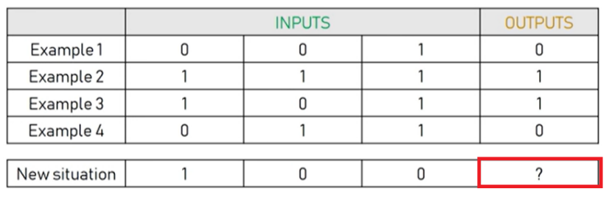

https://www.youtube.com/watch?v=YFb7hgJTbKo

https://www.youtube.com/watch?v=kft1AJ9WVDk

import numpy as np

def signoid(x):

return 1 / (1 + np.exp(-x))

def signoid_derivative(x):

return x * (1-x)

inputs = np.array([[0,0,1],

[1,1,1],

[1,0,1],

[0,1,1]])

target = np.array([[0,1,1,0]]).T

np.random.seed(1)

weigts = (2 * np.random.rand(3,1)) - 1

print('Random starting weights ',weigts)

for epocas in range(50000):

input_layer = inputs

#TRASPUESTA???

outputs = signoid(np.dot(input, weights))

error = outputs - target

adjustments = error * sigmoid_derivative(outputs)

weights += np.dot(input.T, adjustements)

print('Weights after training ', weigts)

print('After trainining ',outputs)